Learn ENGLISH!  Brave Spear English School  BUSINESS ENGLISH  EFL for PROFESSIONALS  CONVERSATION – EIKEN Tests  Professional EFL (English as a Foreign Language) teacher  Experienced teaching Professionals, Businesspeople, Investors, Medical personnel, university students, teenagers...  B. Ed. (TEFL); MA and BA in Politics | 
BUSINESS & PROFESSIONAL  lesson  ¥ 5, 000 | PRIVATE  lesson  ¥ 3,000 | GROUP  Lesson  ¥ 2,000/person  (2 - 4 persons) | EIKEN  TOEFL, TOEIC  Lesson  ¥ 2,000 | ONLINE  Lesson  ¥ 2,000 | CHILDREN  Lesson  (6-12)  ¥ 2,000
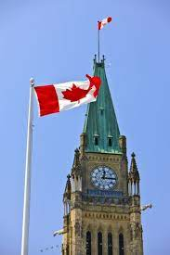 | Nationality: Canada (Ottawa and Montreal)  Education: ESL Certificate - Panasonic OTC (Overseas Training Center)  B. Ed. (Baccalaureate in Education, TEFL) Concordia U.  Certificate (TEFL) Concordia University  MA (Political Studies) McGill University  BA (Political Studies) University of Quebec in Montreal)  Experience: Teacher of EFL in Japan, to Business and Professionals (Panasonic’s GOLD Program, ECC, ALC, GABA …), at universities (Kyoto Gaidai, Ritsumeikan, Tezukayama, …), to private students and children …  Languages: English and French, Japanese (Lower Intermediate)
Brave Spear  English School |  | LEVESQUE Gerard Pierre  Senrioka, Suita-shi, Osaka-fu

LEVESQUE  from Epi Skopos (Greek)  Over Seer - 監督者 | GERARD  from Ger Hard (German)  Brave Spear - 勇敢 槍 | PIERRE  from Petros (Greek)  Stone - 結石
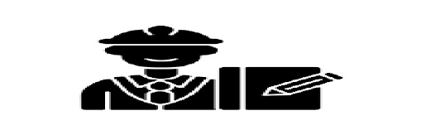 | 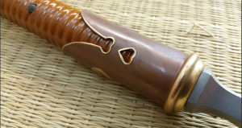 | 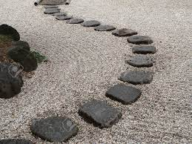

Phone: 080 7034 0561  \  Mail: gerard.pierre.levesque@hotmail.com  Web site: https://bravespearenglish.school/  LINE: https://line.me/ti/p/aRbRIczA_F | 